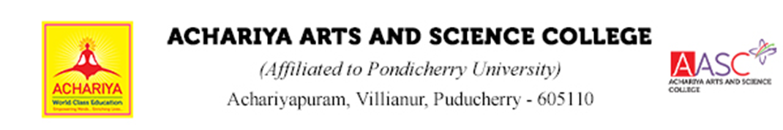

DEPARTMENT | :MATHEMATICS
DOCUMENT | :ALUMNI ACTIVITY REPORT
ACADEMIC YEAR | :2024-2025



DEPARTMENT OF MATHEMATICS
ALUMNI ACTIVITY ODD SEMESTER
2024-2025
- The Department of Mathematics Organised an Alumni Talk on “Human Trafficking and Drug Abuse” by our Alumni Mr. Lawrence, Financial Admin, St. Joseph’s of Cluny, Social Service and on “Students Stress Management in Current Advancements” by the Alumni of department of BBA, Ms. Jenifar, Medical and Psychiatric Social Worker.

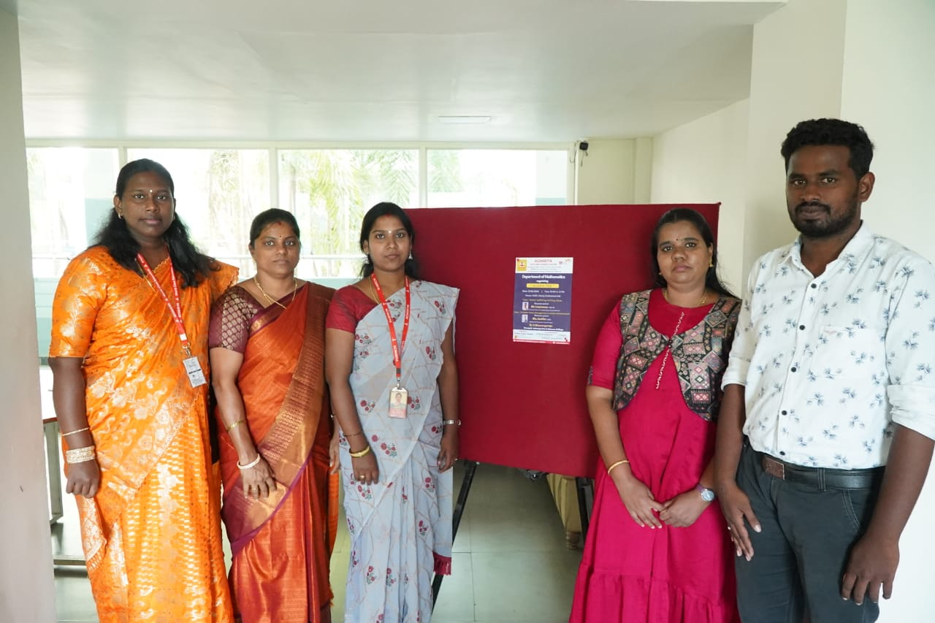
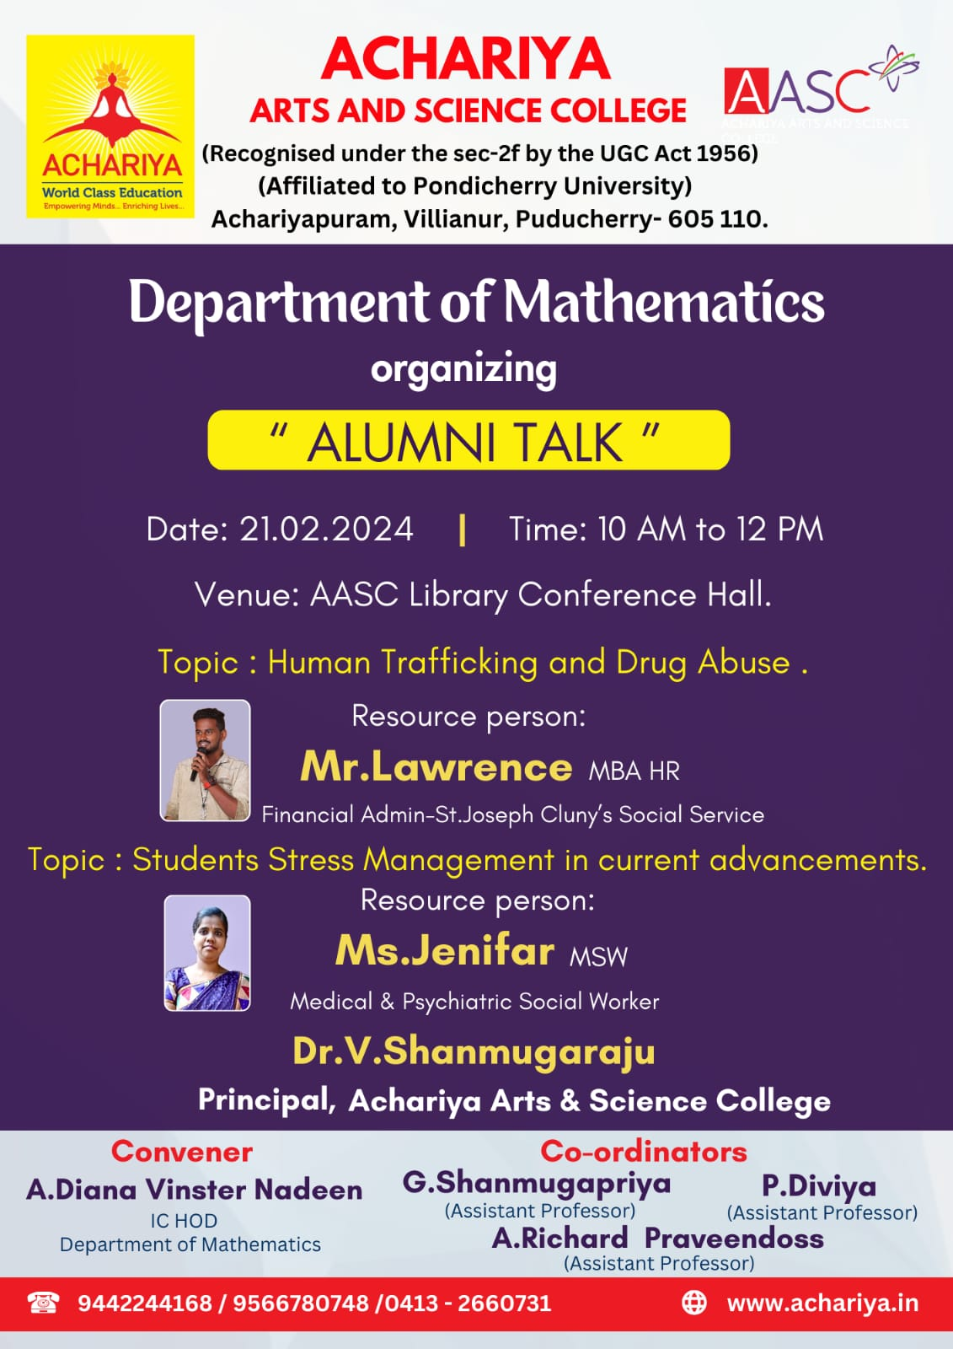

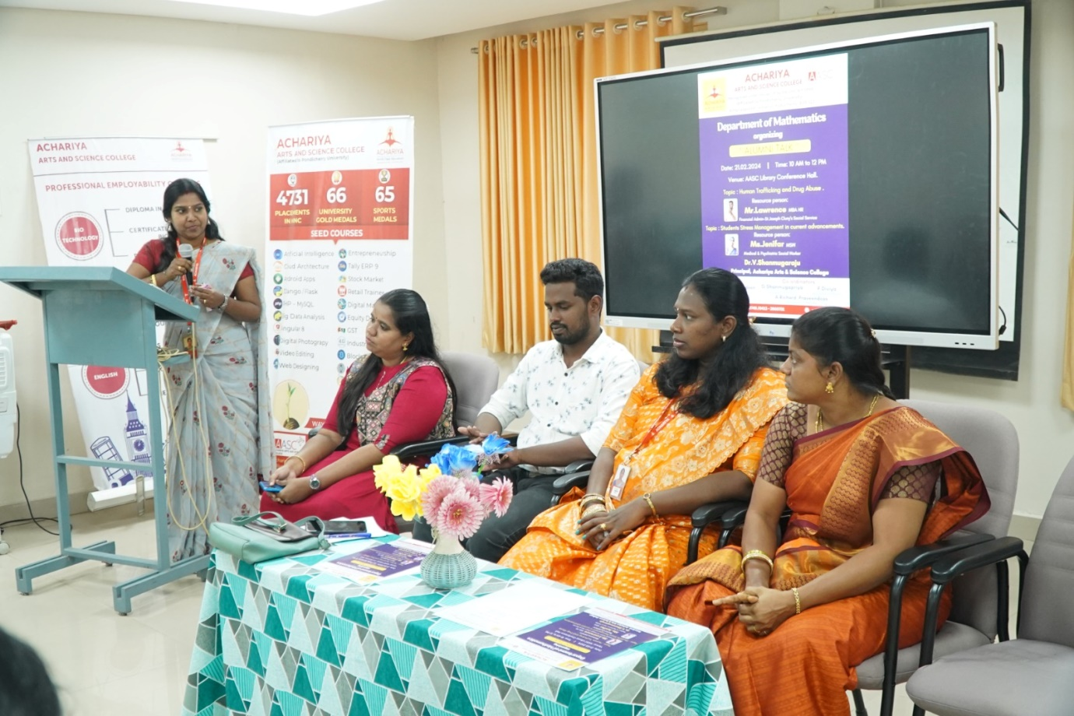

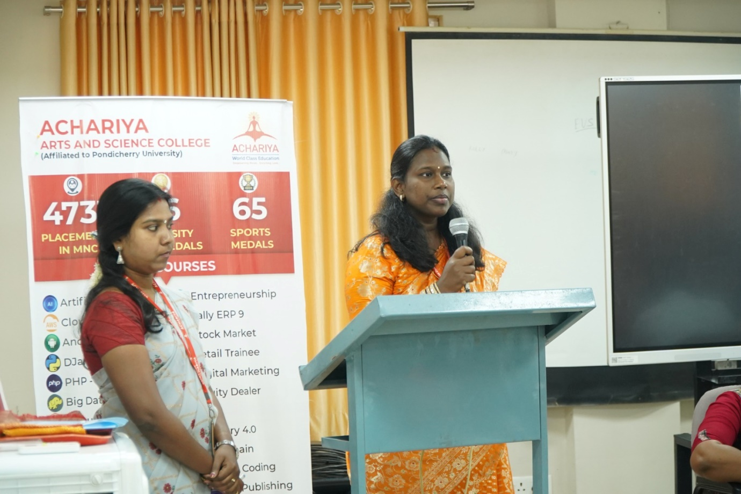

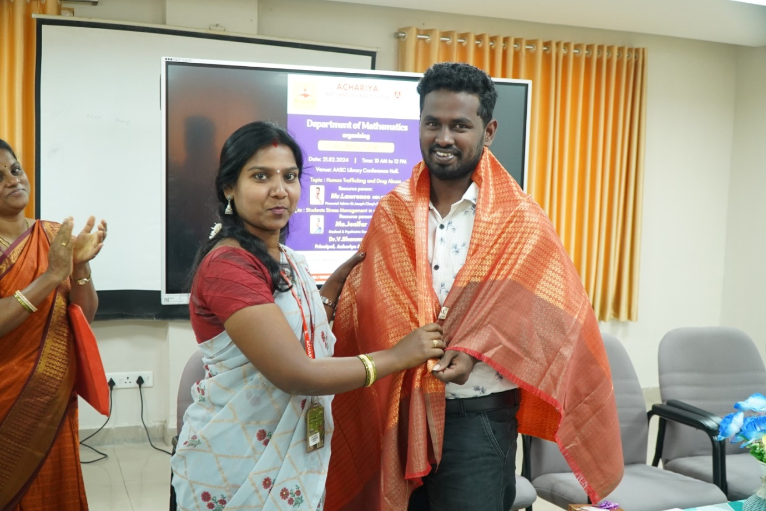

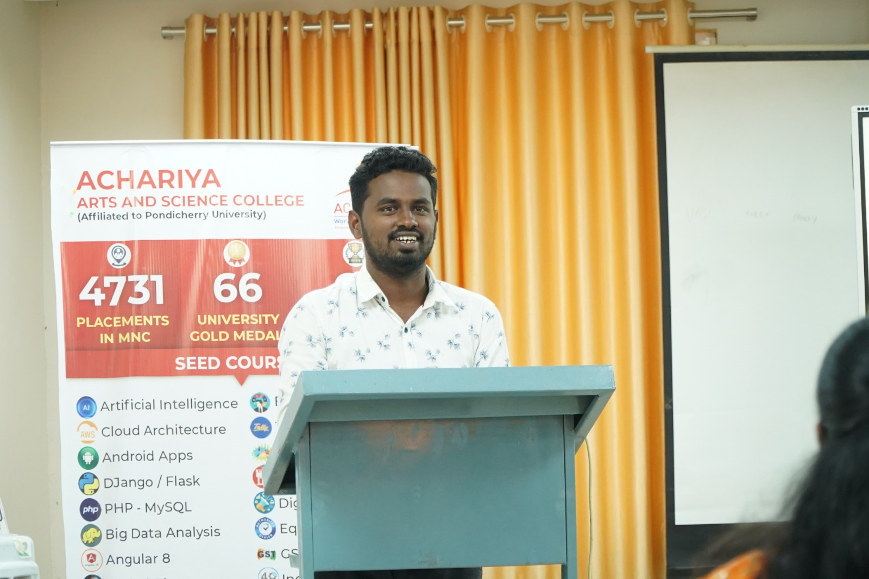

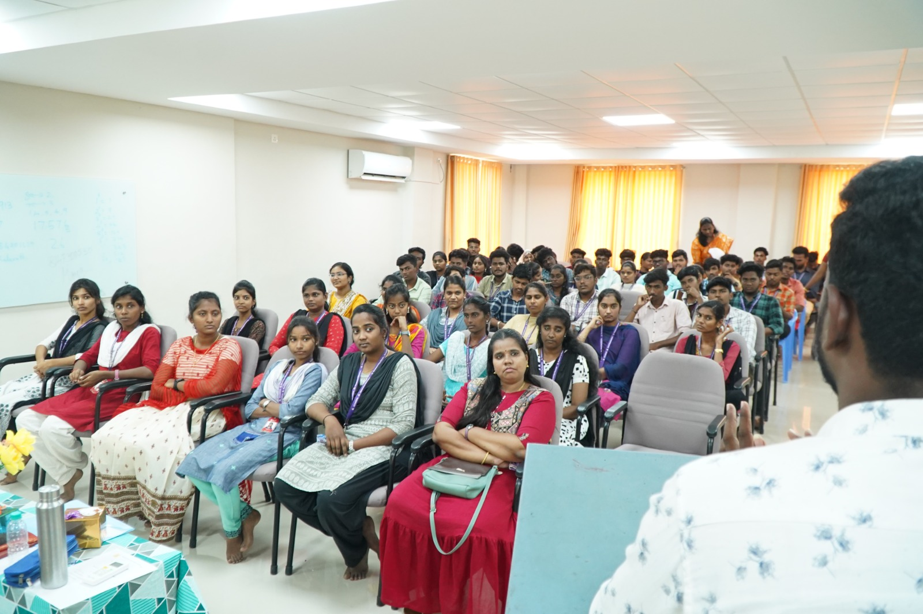

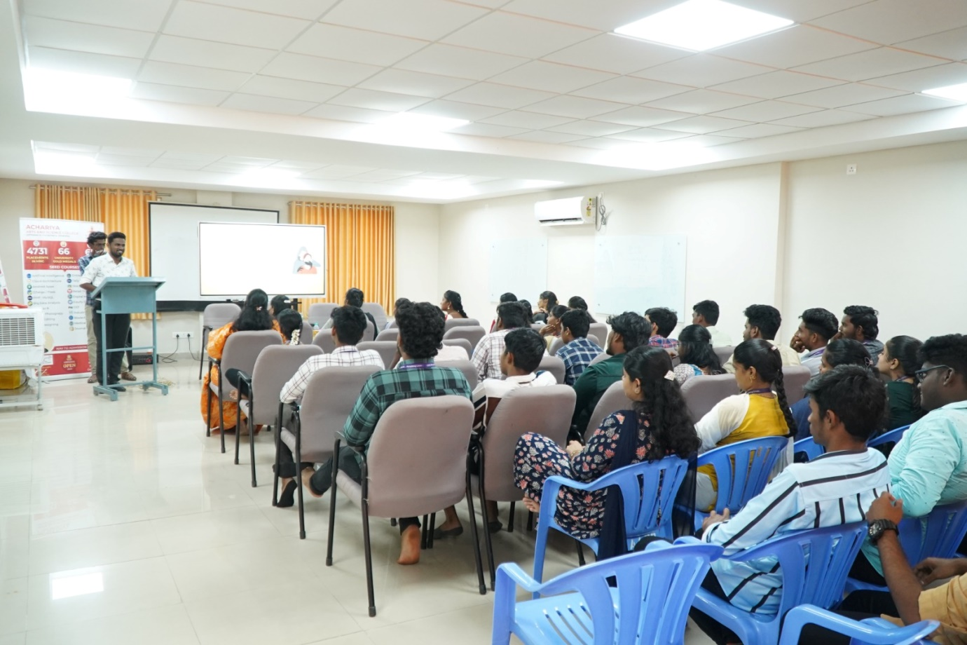

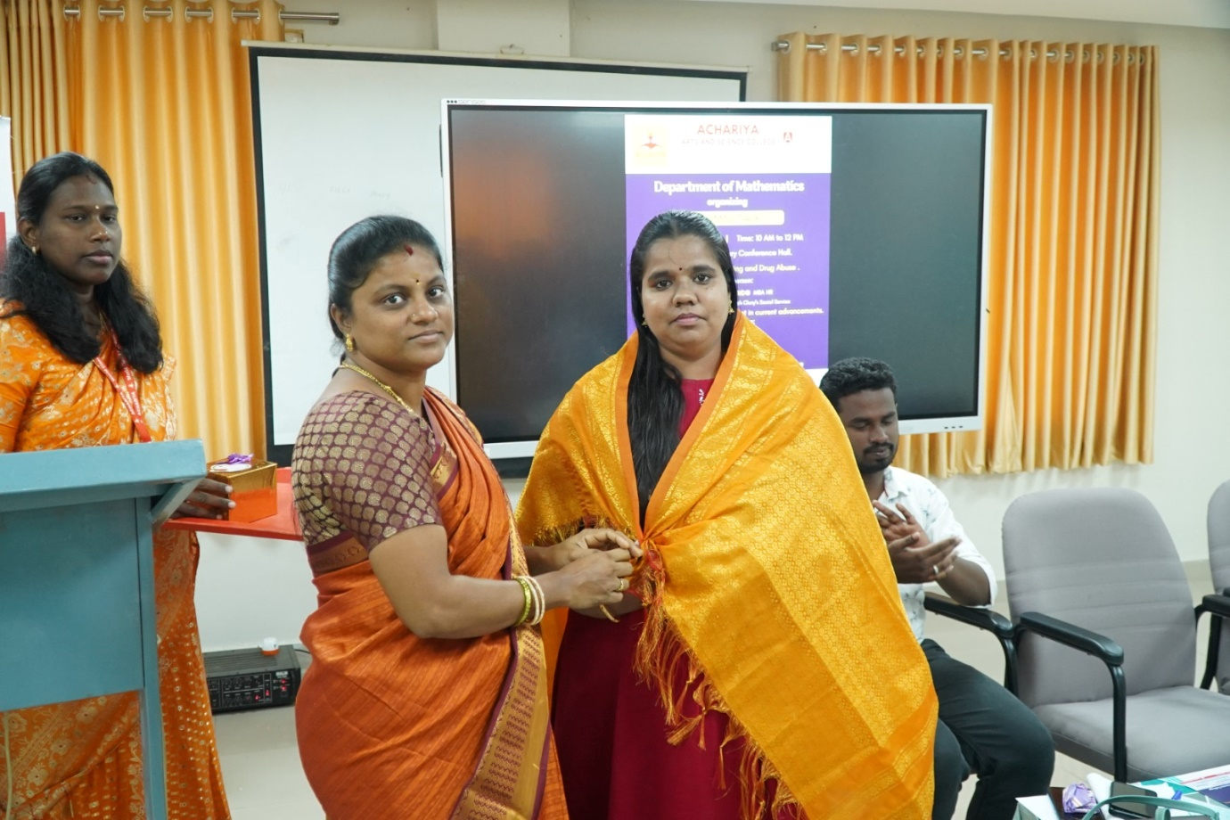

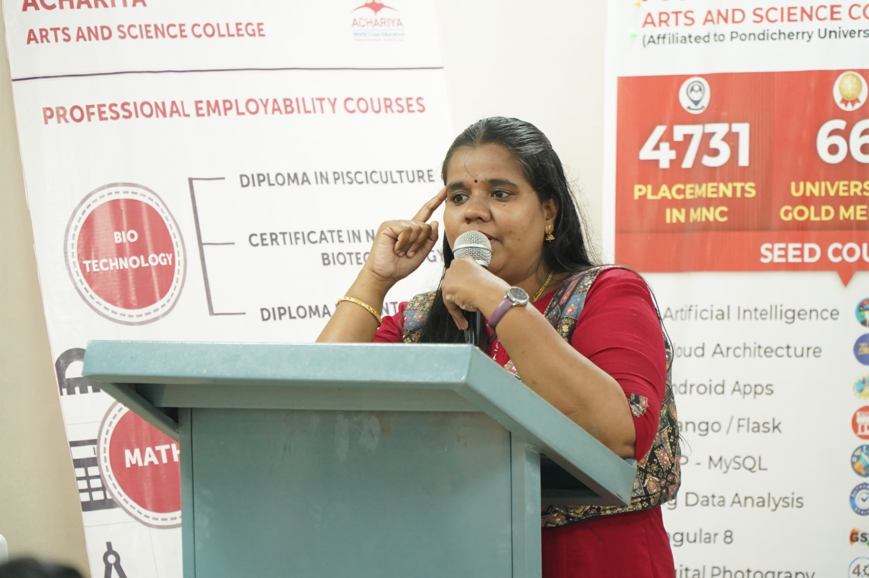

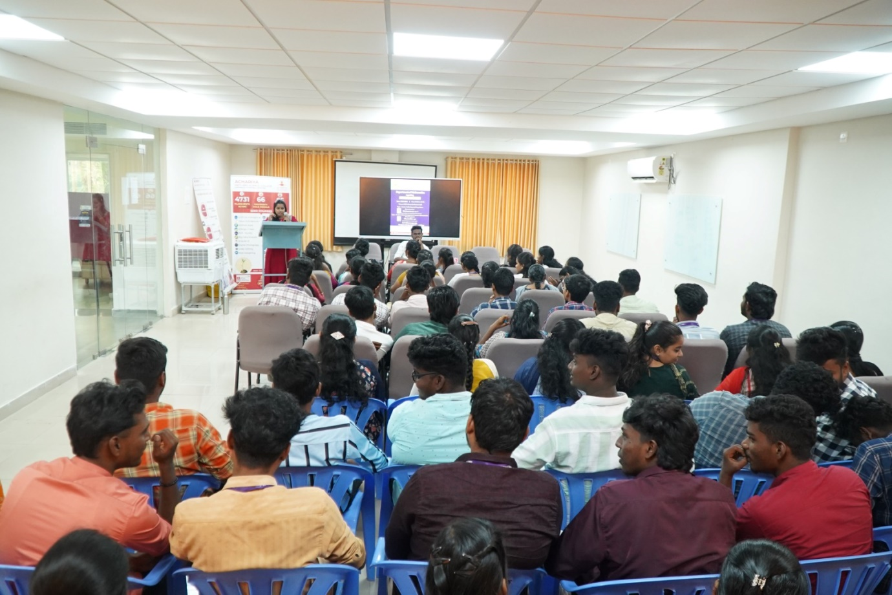

- Department of Mathematics Organized a Two Days Self- Defence Workshop entitled Girls Lead Girls on 5th and 6th of November 2024.
Day 1: All the First year Girls
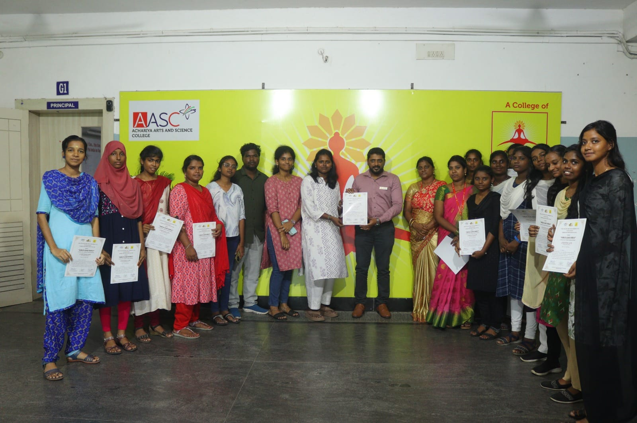

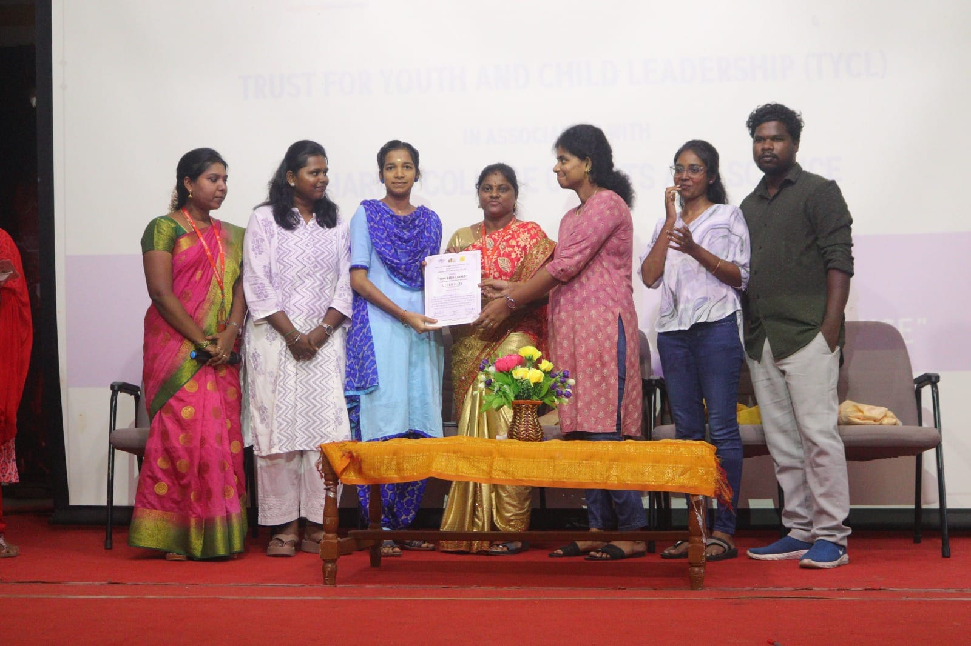

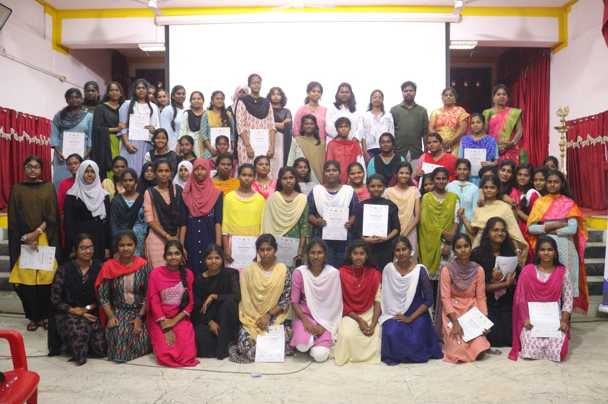

Day 2: All the Second year Girls

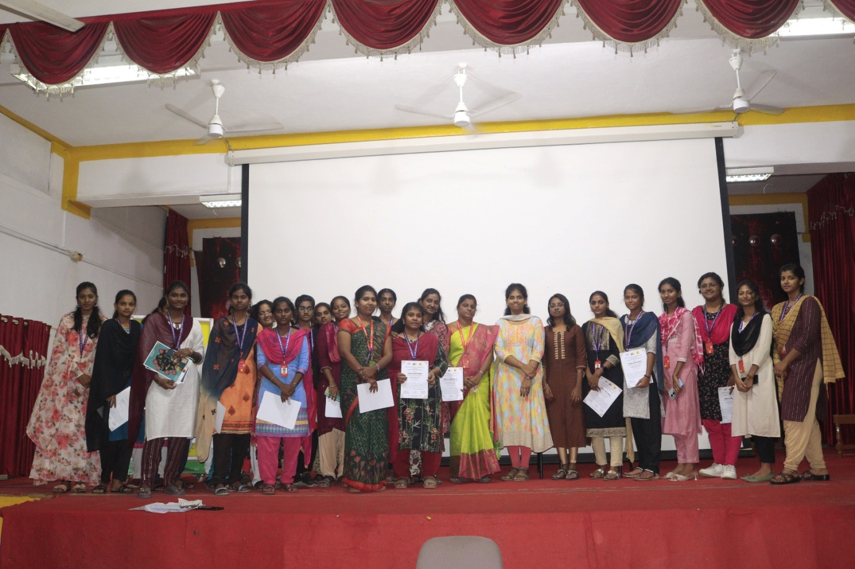

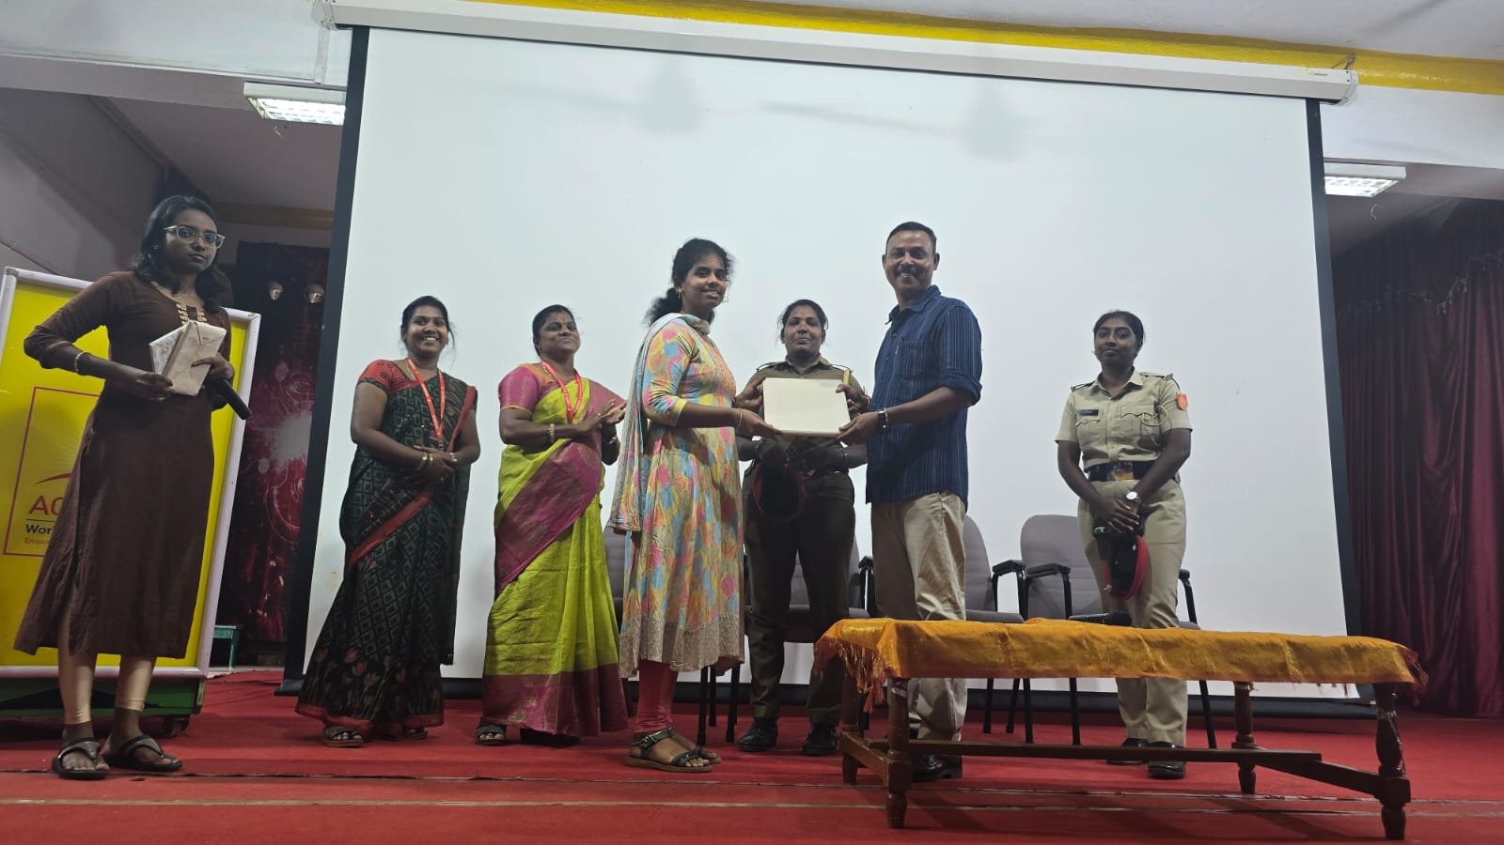

- The Department of Mathematics Organised an Alumni Talk on “Studies and Career Overseas” by our Alumni Ms. Swathy Moorthy, Business Administration and Marketing, Paris, France on 11th April 2025.

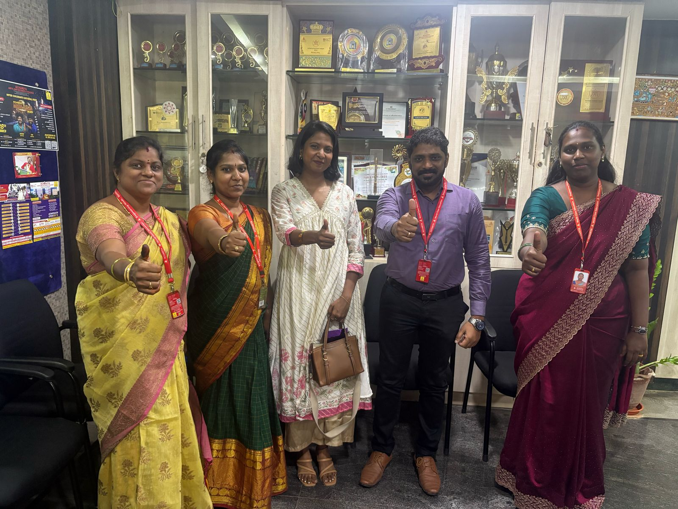

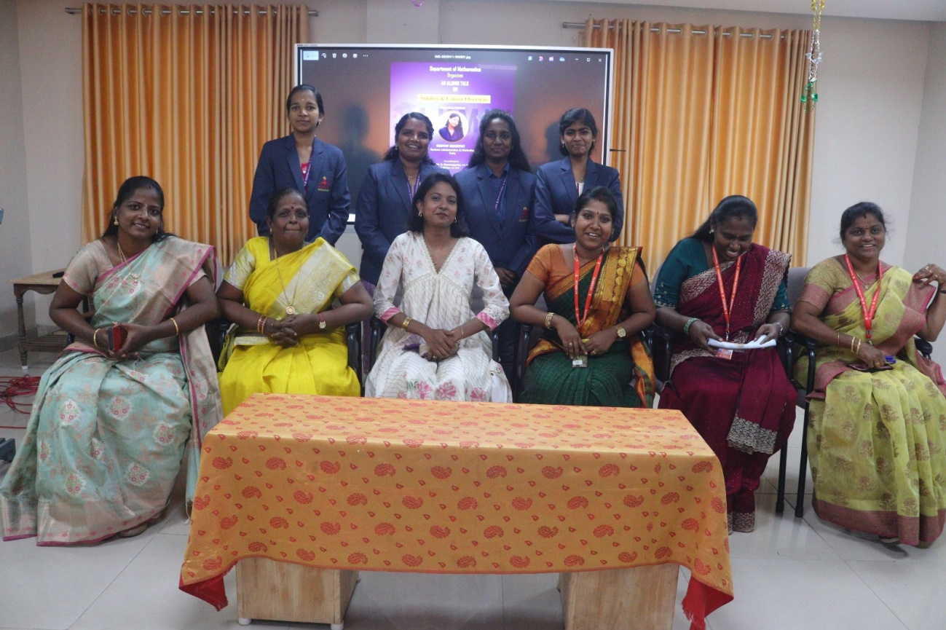
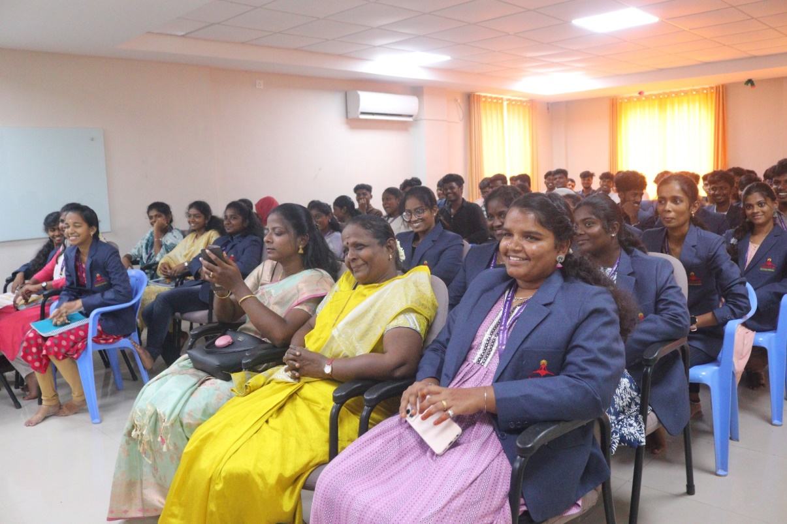

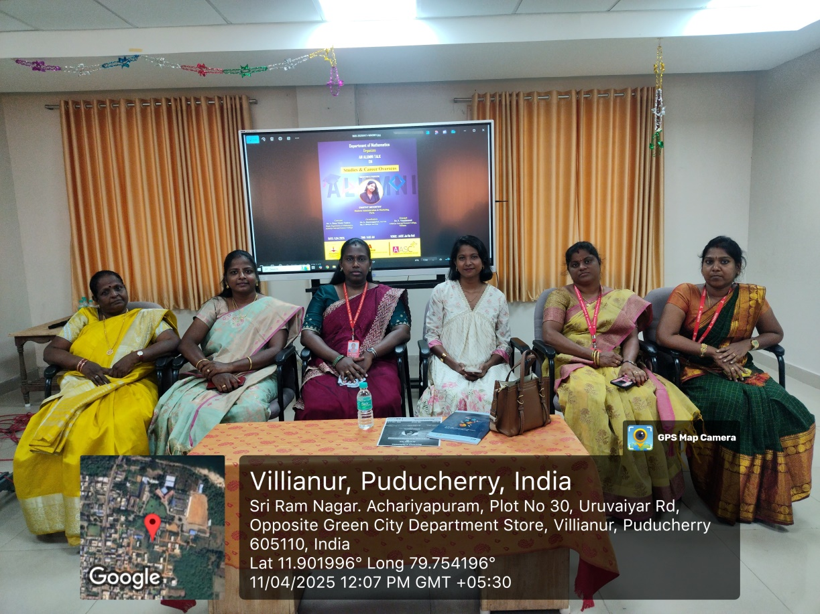
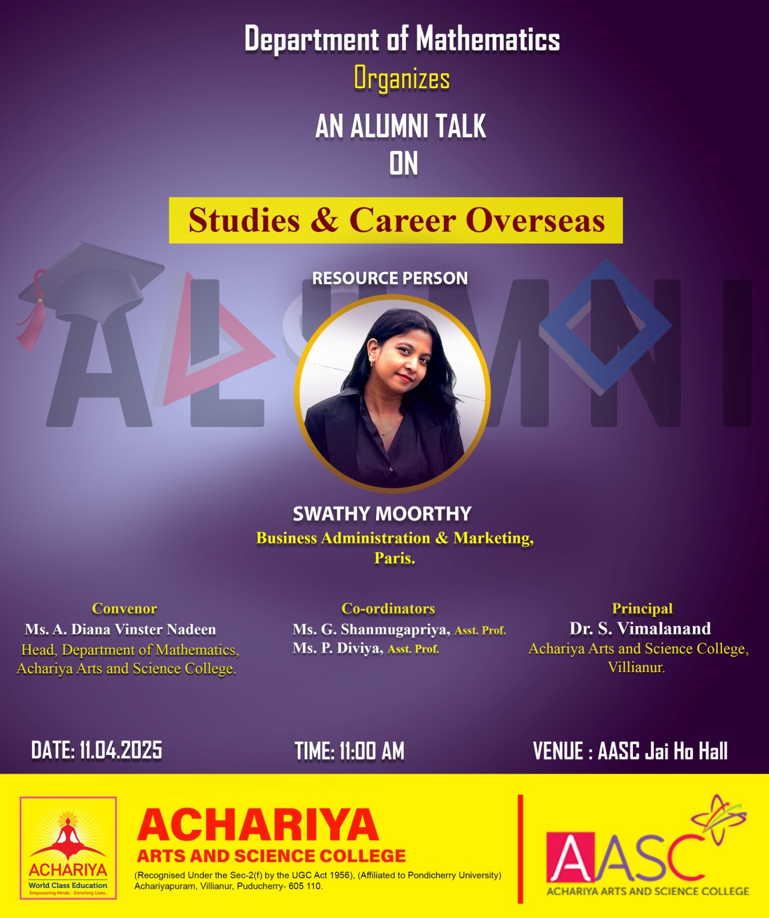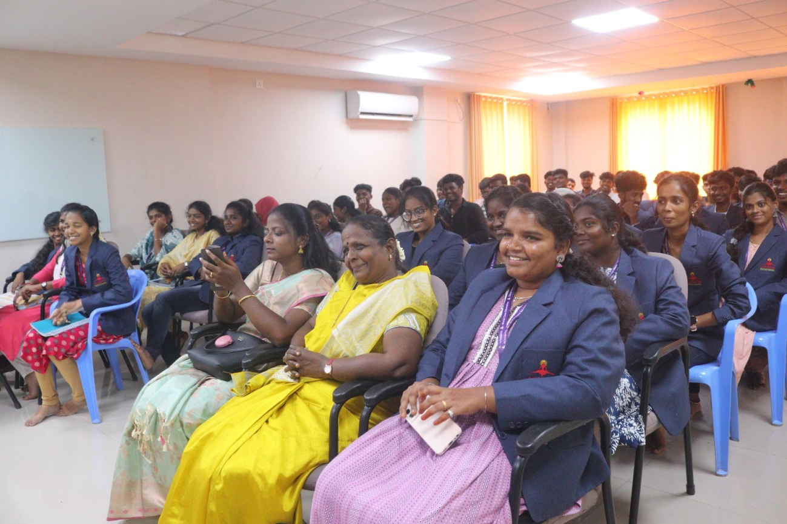

Signature of the HOD

